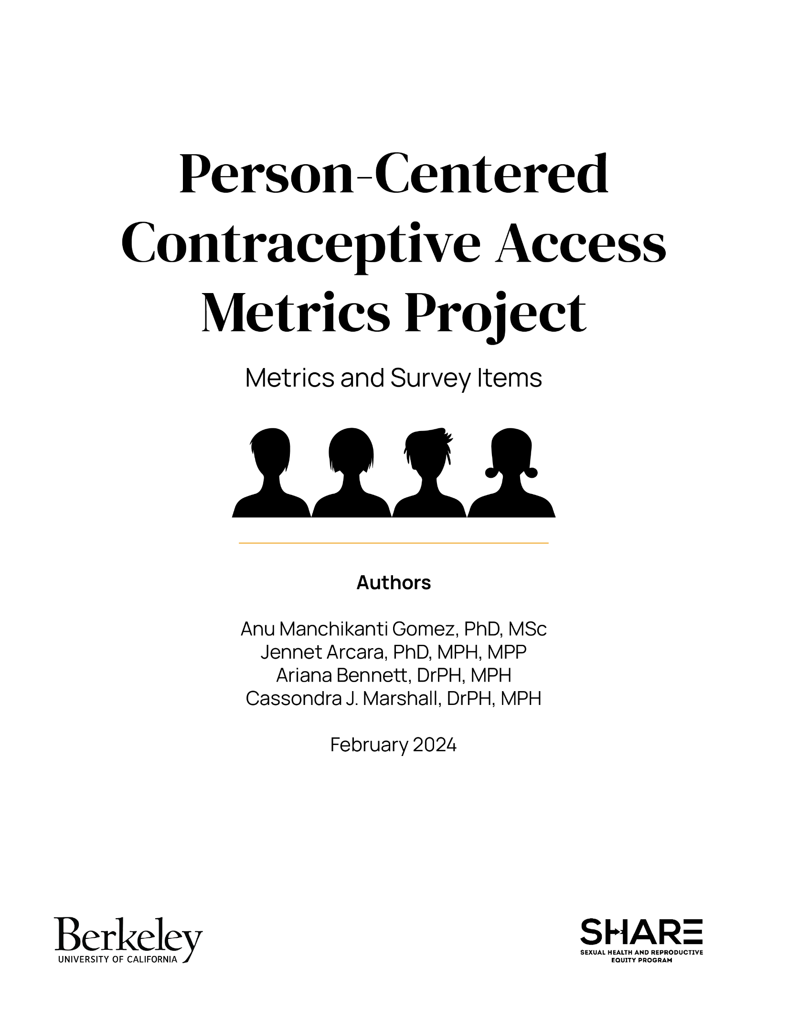

Table of Contents
Introduction 3
Project Goals 4
Project Overview 4
Metric 1: Use of Preferred Method of Contraception 5
Metric 2: Receipt of Contraception from Preferred Source 9
Metric 3: Has Enough Information to Choose Best Contraception for Them 12
Metric 4: Experienced Challenge or Delay Getting Contraception in Past Year 13
Resources 15

Introduction

Being able to manage one’s fertility in an acceptable and desired way is a key component of reproductive well-being. However, existing measures do not consider whether individuals’ contraceptive needs—as they define them—are being met. Without capturing this important aspect of contraceptive use and access, our ability to conduct surveillance and to design strategies to increase access in ways that are person-centered and attend to the needs of under-resourced populations—particularly communities of color—is severely constrained. Further, without accurate person-centered data, current efforts to expand contraceptive access may result in inefficiency and wasted resources.
Current methodologies do not enable us to identify the level of person-centered unmet contraceptive need or demand in the United States. For example, in existing measures, unmet need for contraception is operationalized as the proportion of women not using contraception among those who are fecund and not seeking pregnancy.^{ii} It assumes that potential users of contraception are those that need contraception. That is, these measures are not based on information about people’s contraceptive needs as they define them but assume that they “ought to be using” contraception because they do not describe themselves as actively seeking pregnancy. Furthermore, the conventional definition of unmet need assumes that all current contraceptive users have their needs met, full stop. Whether they are actually using their preferred method of contraception or have a need to switch or discontinue methods is ignored.
Contraceptive use/non-use or use of effective methods are also inappropriate metrics for understanding whether individuals are able to optimally manage their fertility. There are many reasons why individuals choose to use or not use contraception and why they prefer certain methods or contraceptive attributes. Uptake of certain methods, such as LARCs, is frequently cast as success for contraceptive programs and clinical practice, yet this framing simultaneously reproduces narratives that marginalize under-resourced communities and fails to center their needs.
Relying on contraceptive use overall or use of effective methods specifically as measures of success and the foundation for public health goals means that we have a limited understanding of how to increase contraceptive access and, instead, embed norms into systems that undermine reproductive justice.

Project goals

With funding from Arnold Ventures, we sought to address these gaps and develop new person-centered contraceptive access metrics. Our goals were to (1) develop holistic, person-centered measurement approaches to track contraceptive access; and (2) use these data to enrich national contraceptive surveillance approaches and to develop targeted strategies to improve contraceptive access.
Shifting to a focus on person-centered contraceptive access provides an opportunity to understand the systems and practices where individuals are falling through the cracks and to develop strategies to best serve their needs. Further, this approach can help identify root causes of inequities in access and identify strategies to ameliorate them. Obtaining this information at the national level provides an important opportunity to re-envision how policymakers design and implement contraceptive access programs, including where and how to focus interventions and resources. In particular, national data are critical for setting new directions for public health goals.

Project Overview

Based on stakeholder interviews and a review of existing survey questions, we developed a survey to assess contraceptive needs and access among a national sample in the U.S. Survey items were refined based on cognitive interviews and expert review. We fielded a nationally representative survey using NORC’S AmeriSpeak Panel. The sample included 3,059 individuals ages 15-44, assigned female sex at birth, not sterilized or known to be infertile, and English- or Spanish-speaking. We convened stakeholders in a series of 3 working group meetings to select and develop person-centered metrics related to contraceptive need and access. The working group reviewed initial data and selected 4 priority metrics of person-centered contraceptive access: 1) use of preferred method of contraception, 2) use of preferred service delivery approach, 3) having enough information to choose the best contraception for oneself, and 4) experiencing a challenge or delay obtaining contraception in the past year. In addition to the survey questions needed to construct these metrics, this document includes relevant follow-up questions that may be helpful for contextualizing the data.

Metric 1: Use of Preferred Method of Contraception

Construction

- Numerator: Number of people who report they are using their preferred method. This is operationalized as responding “no” to the main question below.
- Denominator: “Current and prospective contraceptive users.” We define this as anyone reporting currently using a method of contraception and current non-users who report there is a method they would rather be using.

Main questions

Is there a method of birth control that you would like to use but you are not currently using?
RESPONSE OPTIONS:
- Yes
- No
- I don’t know

Note: We recommend the addition of “right now” to the main question. (i.e., Is there a method of birth control that you would like to use right now but are not currently using?)

Categorization instructions:
- First, those responding “yes” were categorized as NOT using their preferred method; those responding “no” were categorized as using their preferred method; those responding “I don’t know” were categorized as uncertain.
- Second, for current contraceptive users, we refined this classification using the following questions, asked about each current contraceptive method:
  - Do you want to stop using [current method] in the next year? (yes; no; maybe)
  - [If yes]: Please select the statement that best describes when you want to stop using [current method].
    - I want to stop using [current method] as soon as possible.
    - I want to stop using [current method] sometime in the next 6 months.
    - I want to stop using [current method] sometime in the next year.

Respondents who wanted to stop any of their current methods as soon as possible were recategorized as “uncertain” on the preferred method use metric because their desire to discontinue their method(s) made it unclear whether they were using their preferred method mix.

Follow-up questions

1. What method(s) of birth control would you rather be using? You can select more than one method.

RESPONSE OPTIONS:
- Birth control pills (the pill)
- The birth control patch, like Xulane or Twirla
- A vaginal ring, like NuvaRing or Annovera
- Injectable birth control, like Depo-Provera or DMPA (the shot)
- Birth control implant, like Nexplanon (implant in your arm)
- An IUD or intrauterine device with hormones, like Mirena or Liletta
- A copper IUD (Paragard)
- Emergency contraception, like Plan B or Ella (the “morning after pill”)
- A partner’s vasectomy method of sterilization
- The tubal ligation, “getting your tubes tied,” or Essure methods of sterilization
- External condoms (sometimes called “male condoms”)
- Internal condoms (sometimes called “female condoms”)
- Non-hormonal contraceptive gel inserted into the vagina before sex (Phexxi)
- Spermicide inserted into the vagina before sex, like VCF or Gynol II
- A diaphragm
- A cervical cap
- A contraceptive sponge, like the Today Sponge
- Withdrawal or pulling out
- Fertility awareness-based methods, including the rhythm or calendar method (tracking your menstrual cycle on a calendar or app), periodic abstinence (only having sex on certain days of the month), and/or methods where you monitor your basal body temperature or cervical mucus
- Another method.
- I don’t know which method I would rather be using.
- None of these methods.

Note: The original version of this question included “Not having sex at all (abstinence)” as a response in the list of birth control methods. However, abstinence was not classified as a contraceptive method in analyses, so we are no longer including it in this list.

1a. [If response #20]: In response to the previous question, you said “Another method.” Please specify what method you would rather be using: [Write-in response]

1b. [If responded with 2 methods they would rather be using]
Please rank these methods of birth control, with 1 being the method you’d choose as your first choice and 2 being the method you’d choose as your second choice.

1c. [If responded with >2 methods they would rather be using]:
Please rank these methods of birth control from 1 to 3 with 1 being the method you’d choose as your first choice, 2 being the method you’d choose as your second choice, and 3 being the method you’d choose as your third choice.

2. What is the reason(s) you are not currently using [fill in preferred method]? Select all that apply.

RESPONSE OPTIONS, RANDOMIZE 1-2, 3, 4-8, 9-13, 14-15, 16-18
- I’m not currently having sex that could result in pregnancy (e.g., penile-vaginal sex).
- I don’t have sex very often.
- The method interferes with the pleasure of sex.
- [SHOW IF preferred method=vasectomy, external condoms, internal condoms, withdrawal] My partner doesn’t want to use this method.
- [SHOW IF preferred method is NOT vasectomy, external condoms, internal condoms, withdrawal] My partner doesn’t want me to use this method.
- Someone else in my life doesn’t want me to use this method.
- I don’t want my partner or family to find out that I use this method.
- My healthcare provider suggested I use something else.
- [SHOW IF preferred method is NOT withdrawal, fertility awareness] I had a problem getting this method when I needed it.
- [SHOW IF preferred method is NOT withdrawal, fertility awareness] It’s too hard to get to a place to get this method (no transportation or childcare, cannot take time off work).
- [SHOW IF preferred method is NOT withdrawal, fertility awareness] I don’t have a healthcare provider I trust.
- [SHOW IF preferred method is NOT withdrawal, fertility awareness] I don’t know where I can get it.
- [SHOW IF preferred method is NOT withdrawal, fertility awareness] It wasn’t available at my doctor’s office, clinic, or pharmacy.
- [SHOW IF preferred method is NOT withdrawal, fertility awareness] I can’t afford it.
- [SHOW IF preferred method is NOT withdrawal, fertility awareness] Another method is cheaper.
- [SHOW IF preferred method is NOT withdrawal, fertility awareness] I’m concerned about side effects (like bleeding, cramping, mood swings, or weight gain).
- I’m concerned about the safety of this method.
- I don’t think this method of birth control works.
- Another reason.
- I’m not sure.

Note: Respondents were only shown options that could apply to the preferred method being asked about. E.g., “I can’t afford it” was not shown to people who preferred withdrawal or fertility awareness.

2a. [If response #6]: In response to the previous question, you said “Someone else in my life doesn’t want me to use this method.” Please specify their relationship to you: [Write-in response]

2b. [If response #19]: In response to the question about the reason(s) you are not currently using [insert preferred method], you said “Another reason.” Please specify why you are not currently using [insert preferred method]: [Write-in response]

Metric 2: Receipt of Contraception from Preferred Source

Metric 2a construction: Receipt of contraception from a preferred source

- Numerator: Number of people who most recently obtained the pill, patch, or ring from any of their preferred sources. This was determined based on a match between main questions 1 and 2 below.
- Denominator: Current users of the pill, patch, or ring

Metric 2b construction: Receipt of contraception from most preferred source

- Numerator: Number of people who most recently obtained the pill, patch, or ring from their most preferred source. Most preferred source was determined based on a match between main questions 1 and 2/2b below. If only one preferred source was selected, the match was based on questions 1 and 2. If more than one preferred source was selected, the match was based on questions 1 and 2b.
- Denominator: Current users of the pill, patch, or ring

Main questions

1. The last time you got [insert current method], how did you get it prescribed?

RESPONSE OPTIONS:
- In-person at a doctor’s office or clinic
- In-person at a hospital
- From a telehealth (video or phone) appointment with my regular doctor’s office, clinic, or hospital
- Contacted my provider and they wrote a new prescription without seeing me for any kind of appointment first
- Prescribed by a pharmacist, without seeing a doctor or nurse first
- From an online service that sends it directly to me (like Nurx)
- In another way

1a. [If response #7]: In response to the previous question, you said “In another way.” Please specify how you got [insert current method] prescribed: [Write-in response]

2. If you could choose any way of getting a birth control prescription, how would you prefer to get it? Select all that apply.
RESPONSE OPTIONS:
- In-person at a doctor’s office or clinic
- In-person at a hospital
- From a telehealth (video or phone) appointment with a doctor’s office, clinic, or hospital
- Prescribed by a pharmacist, without seeing a doctor or nurse first
- Over the counter at a pharmacy or other store (no prescription from any source needed)
- From an online service that sends it directly (like Nurx)
- In another way

Note: The original version of this question included “or the Pill Club” as an example along with Nurx in response option 6 in both questions above. However, as the Pill Club is no longer in business, we suggest removing it from the response option.

2a. [If response #7]: In response to the previous question, you said “In another way.” Please specify how you would prefer to get a birth control prescription: [Write-in response]

2b. [If >1 response to Q2 above]: Which way of getting birth control would you most prefer?

Follow-up question

Why would you prefer to get birth control [insert most preferred way from 2/2b]? Select all that apply.

RESPONSE OPTIONS:
- The cost would be lower.
- I trust the provider there.
- It would be more convenient.
- It would take me less time.
- I feel more in control.
- I am treated with respect.
- I can receive care in my preferred language.
- It would feel more private.
- It’s the only place I can get my method.
- I could use my insurance.
- I would be able to ask questions if I had them.
- It’s where I usually go.
- I can get the method I want there.
- My healthcare provider suggested it.
- A friend, family member, or someone else suggested it.
- Another reason.

[If response #16]: In response to the previous question, you said “Another reason.” Please specify why you would prefer to get birth control [insert preferred way]: [Write-in response]

Metric 3: Has Enough Information to

Choose Best Contraception for Them

Construction

- Numerator: Number of individuals who respond “yes” to having enough information to decide what birth control is best for them
- Denominator: All respondents, ages 15-44

Main question

Do you feel like you currently have enough information to make a decision about the birth control method(s) that is best for you?

RESPONSE OPTIONS:
- Yes
- No
- I’m not sure

Follow-up question

What information do you feel that you need to make a decision about the birth control method(s) that is best for you? [Write-in response]

Metric 4: Experienced Challenge or Delay

Getting Contraception in Past Year

Construction

- Numerator: Number of people who report “yes” to experiencing a challenge or delay in the past year
- Denominator: People who have ever used or tried to obtain a birth control method that is a device or product (i.e., not withdrawal or fertility awareness methods)

Main question

In the past 12 months, have you encountered any challenges or delays in getting the birth control method you wanted?

RESPONSE OPTIONS:
- Yes
- No

Follow-up question

What challenges or delays did you encounter in getting the birth control method that you wanted? Select all that apply.

RESPONSE OPTIONS:
- It was too expensive.
- I didn’t have insurance.
- My health insurance doesn’t cover it.
- It was too hard to get to a place to get the method I wanted (no transportation or child care, couldn’t take time off work).
- I didn’t know where I could get it.
- The method that I wanted was not available at my doctor’s office, clinic, or pharmacy.
- My source of healthcare is religiously affiliated and does not provide the birth control method I wanted.
- I didn’t want my partner or family to find out that I was trying to get a birth control method.
- The doctor’s office, clinic or pharmacy wasn’t open when I could get there.
- A healthcare provider would not give me the method that I wanted.
- I was treated poorly by a staff person at the doctor’s office, clinic, or pharmacy.
- Something else.

[If response # 12]: In response to the previous question, you said “Something else.” Please specify what challenges or delays you encountered in getting the birth control method that you wanted: [Write-in response]

Resources

Should you use any of these survey questions, please use the following citation:

Gomez, A.M., Arcara J., Bennett, A., Marshall, C.J. (2024). “Person-Centered Contraceptive Access Metrics Project.” Berkeley, CA: Sexual Health and Reproductive Equity Program, University of California, Berkeley.

For more information and to explore our findings, click here.

By surveillance, we refer to ongoing, systematic collection, analysis, and interpretation of data related to family planning, essential to public health program planning, evaluation and policy development.
Bradley SEK, Casterline JB. Understanding Unmet Need: History, Theory, and Measurement. Studies in Family Planning. 2014;45(2):123-150.

